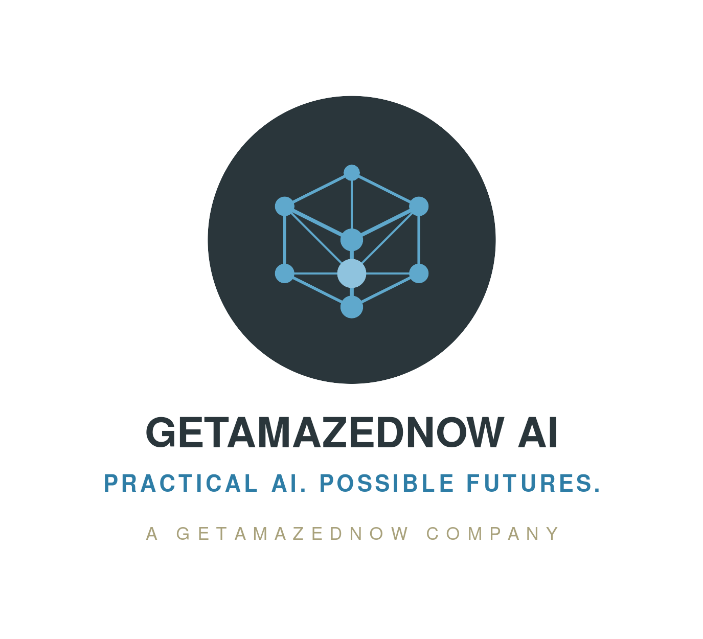
ADSRA · OPEN QUESTION OQ-3
 Autonomous sovereignty: who audits the auditor?
The question
At the highest maturity level, AI agents assess and remediate the organisation’s own sovereignty posture. What evidence would convince a regulator that this agentic remediation is itself well-governed?
Why it matters
This is the model’s most novel contribution and its biggest exposure: the assurance system is itself an AI system, so it needs the same governance as any other AI workload — registered models, scoped tool permissions, budget limits, evidence trails. Without a regulator-credible evidence answer, autonomous assurance stays a slide, not a control. APRA's April 2026 AI letter points the same way: it expects second-line functions able to assess autonomous workflows, and monitoring proportionate to criticality.
Our current position [a considered view, open to challenge]
Treat it as aspirational by design — pilots, not production, are the realistic target inside a 24-month planning window. Agentic assurance must be governed as an AI workload, and depends on strong observability as its telemetry substrate.

What we’re seeking from you
A concrete evidence package a regulator would accept for autonomous remediation: audit-trail schema, human-oversight thresholds proportionate to blast radius, fail-safe behaviours, and model / tool governance.
Where this is most relevant: Risk & regulatory practitioners · Banking

